1: Basic Activities – Write Line, Message Box, Input Dialog, Modify Text, Text to Left/Right, Delay.

Aim: To develop automation in UiPath StudioX demonstrating the activities mentioned above.
Step 1: Create a New Project
- Open UiPath StudioX from the Start Menu.
- Click New Project → Blank Task.
- In the dialog box, give the Project Name as BasicActivitiesDemo.
- Choose a folder location (e.g., Documents\UiPath).
- Click Create to open the workspace.
Step 2: Add Write Line Activity
- In the Activities panel, search Write Line.
- Drag it into the Main workflow.
- In the Text field, type "Hello Automation World!".
- This will display in the Output panel when executed.
Step 3: Add Message Box Activity
- Search Message Box in Activities panel.
- Drag it below Write Line.
- In the Text field, type "Welcome to UiPath StudioX!".
- This will show a popup message when executed.
Step 4: Add Input Dialog Activity
- Search Input Dialog in Activities panel.
- Drag it below Message Box.
- In the Title field, type "User Input".
- In the Label field, type "Enter your name:".
- Create a variable (click the output box → + → Create new variable) → name it UserName.
Step 5: Modify Text Activity
- Search Modify Text → drag it below Input Dialog.
- Select Combine Texts option.
- Add: "Hello " + UserName + "! Welcome to Automation.".
- Store output in variable ModifiedText.
Step 6: Text to Left/Right Activity
- Search Text to Left/Right → drag it below Modify Text.
- Select Text to Left of option.
- Input: Text to split = ModifiedText, Delimiter = "!".
- Store result in variable LeftText.
Step 7: Add Delay Activity
- Search Delay → drag it below Text to Left/Right.
- Set Duration to 00:00:05 (5 seconds).
Step 8: Display Final Message
- Add another Message Box below Delay.
- In Text field, type: "Final Message: " + ModifiedText.
Step 9: Save and Run the Project

Result: The automation was successfully implemented and executed in UiPath StudioX.
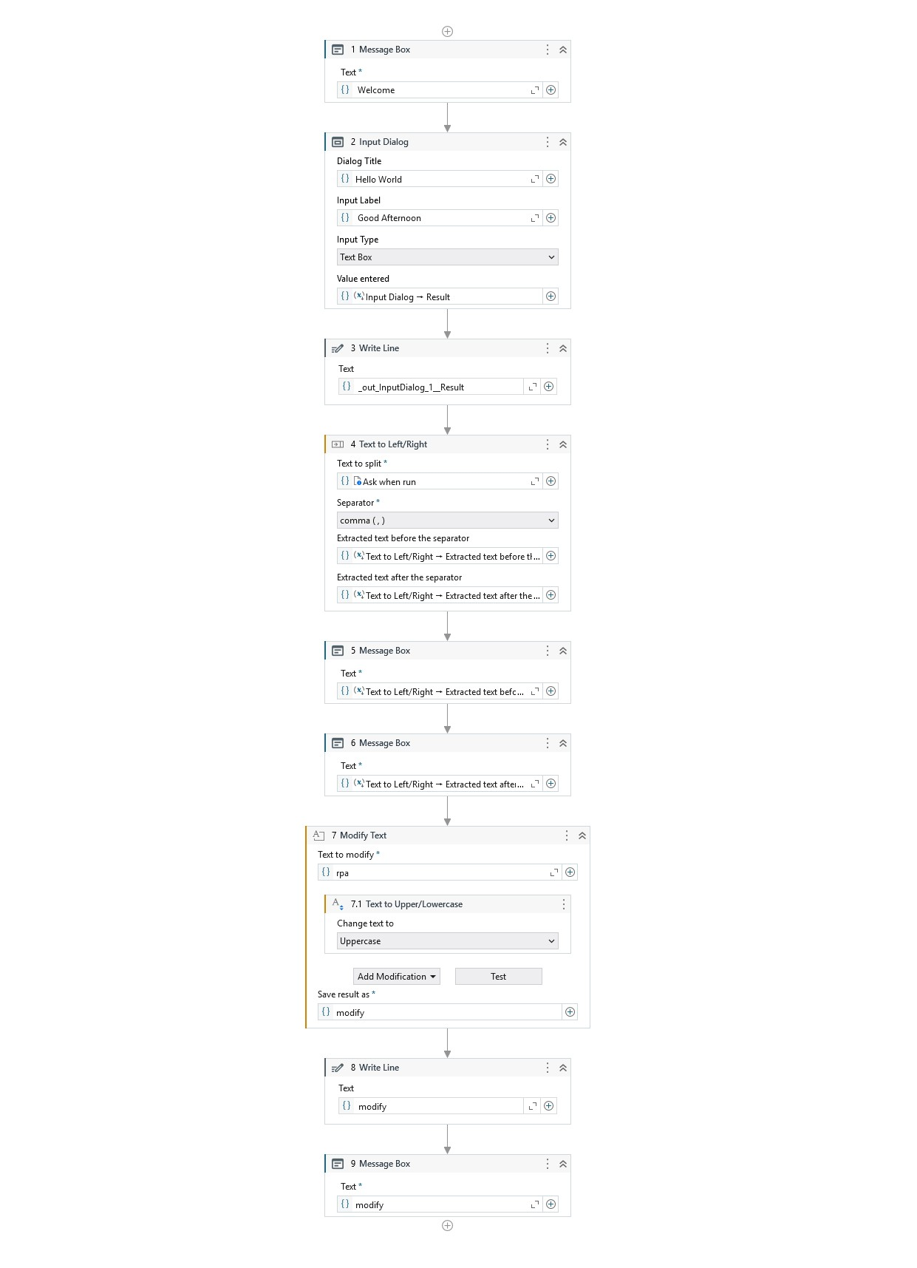
2. Develop automation in UiPath StudioX to demonstrate the following activities: if, Switch., Repeat Number Of Times. , Skip Current, Exit Loop.

Step 1: Create a New Project
- Open UiPath StudioX from Start Menu.
- Click on New Project → Blank Task.
- In the dialog box, give the Project Name as ControlFlowDemo.
- Choose a location folder (e.g., Documents\UiPath).
- Click Create to open a new workspace.
Step 2: Add Input Dialog Activity
- In the Activities panel, search Input Dialog.
- Drag it into the Main workflow.
- In the Title field, type "User Input".
- In the Label field, type "Enter a number:".
- Click on the Output box → + → select Create new variable → name it num.
- This stores the user input number for later use.
Step 3: Add If Activity
- Search If in Activities panel → drag it below Input Dialog.
- In the Condition, enter num > 10.
- In Then branch → add Message Box → Text: "Number is greater than 10."
- In Else branch → add Message Box → Text: "Number is less than or equal to 10."
Step 4: Add Switch Activity
- Search Switch → drag below If activity.
- Set Expression to num Mod 2.
- Add Case 0 → Message Box: "Even number."
- Add Default → Message Box: "Odd number."
Step 5: Add Repeat Number Of Times Activity
- Search Repeat Number Of Times → drag below Switch activity.
- Set Number of Times to 5.
- Inside the loop → add Write Line → Text: "Loop Count: " + CurrentIteration.
Step 6: Add Skip Current & Exit Loop
- Inside the Repeat loop → add If → Condition: CurrentIteration = 3 → add Skip Current activity.
- Add another If → Condition: CurrentIteration = 4 → add Exit Loop activity.
Step 7: Save and Run the Project

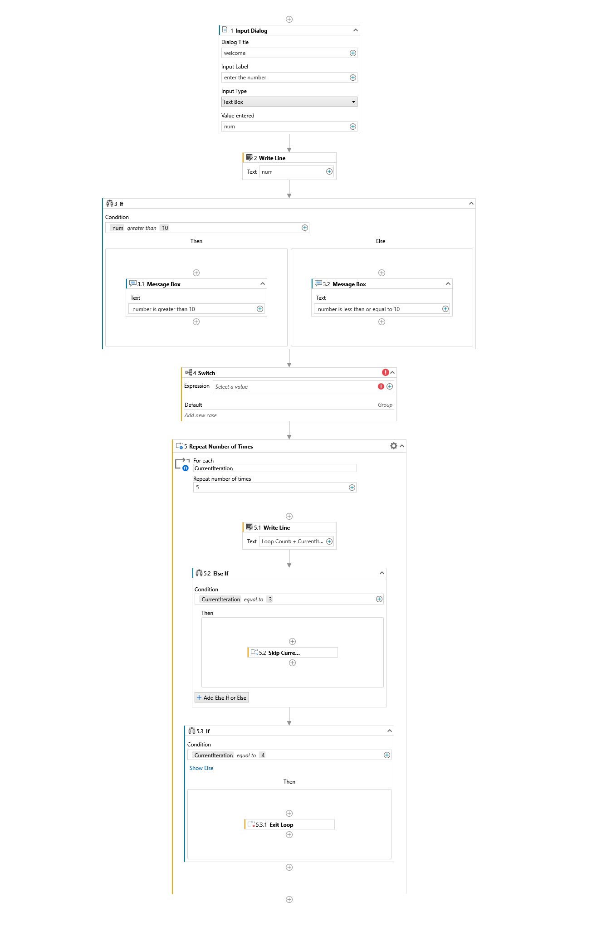
3. Develop UI automation in UiPath StudioX to demonstrate the following activities: Use Application/Browser, Go To URL, Navigate Browser, Highlight and Take Screenshot

Step 1: Create a New Project
- Open UiPath StudioX from the Start Menu.
- Click New Project → Blank Task.
- In the dialog box, give the Project Name as BrowserAutomationDemo.
- Choose a location folder (e.g., Documents\UiPath).
- Click Create to open a new workspace.
Step 2: Use Application/Browser Activity
- In the Activities panel, search Use Application/Browser.
- Drag it into the Main workflow.
- Click Indicate Application/Browser on Screen and select your browser (Chrome/Edge).
- This sets the scope for all browser activities.
Step 3: Go To URL Activity
- Inside the Use Application/Browser scope, search Go To URL.
- Drag it inside the scope.
- In the URL field, enter: https://www.google.com.
- This opens Google’s homepage.
Step 4: Navigate Browser Activity
- Search Navigate Browser in Activities panel.
- Drag it below Go To URL.
- Enter the URL: https://www.wikipedia.org.
- This navigates the browser to Wikipedia.
Step 5: Highlight Activity
- Search Highlight in Activities panel.
- Drag it inside the browser scope.
- Click Indicate Element on Screen → select an element, e.g., search bar.
- This visually highlights the element during execution.
Step 6: Take Screenshot Activity
- Search Take Screenshot in Activities panel.
- Drag it inside the browser scope.
- In Save To, select a folder and file name (e.g., C:\UiPath\Screenshot.png).
- This captures a screenshot of the browser window.
Step 7: Save and Run the Project

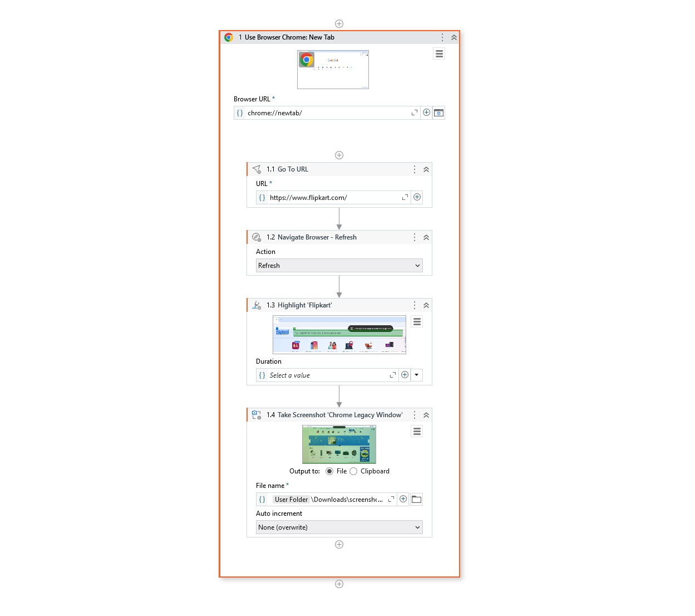

4. Develop UI automation in UiPath StudioX to demonstrate the following activities: Check App State, Click, Type Into, Select Item, Check/Uncheck, Get Text, Get Attribute, Extract Table Data and Hover.

Step 1: Create a New Project
- Open UiPath StudioX from Start Menu.
- Click New Project → Blank Task.
- In the dialog box, give the Project Name as UIAutomationDemo.
- Choose a folder location (e.g., Documents\UiPath).
- Click Create to open a new workspace.
Step 2: Use Application/Browser Activity
- In Activities panel, search Use Application/Browser.
- Drag it into the Main workflow.
- Click Indicate Application/Browser on Screen → select the target application or website.
Step 3: Check App State Activity
- Search Check App State → drag it inside the application scope.
- Indicate the UI element you want to check (e.g., a button or label).
- This ensures the element exists before performing further actions.
Step 4: Click Activity
- Search Click → drag it below Check App State.
- Click Indicate Element on Screen → select the button or link you want to click.
Step 5: Type Into Activity
- Search Type Into → drag it below Click activity.
- Indicate the input field → enter sample text (e.g., "Hello UiPath").
Step 6: Select Item Activity
- Search Select Item → drag it below Type Into.
- Indicate the dropdown list → choose a value (e.g., "Option 1").
Step 7: Check/Uncheck Activity
- Search Check/Uncheck → drag it below Select Item.
- Indicate the checkbox → select Check or Uncheck option.
Step 8: Get Text & Get Attribute Activities
- Search Get Text → drag it below Check/Uncheck → indicate label/text element.
- Store the output in variable textValue.
- Search Get Attribute → drag it below Get Text → indicate element → choose attribute (e.g., innerText) → store in variable attrValue.
Step 9: Extract Table Data Activity
- Search Extract Table Data → drag it below Get Attribute.
- Indicate the table element → store data in a data table variable tableData.
Step 10: Hover Activity
- Search Hover → drag it below Extract Table Data.
- Indicate the element you want to hover over → cursor moves over it during execution.
Step 11: Save and Run the Project

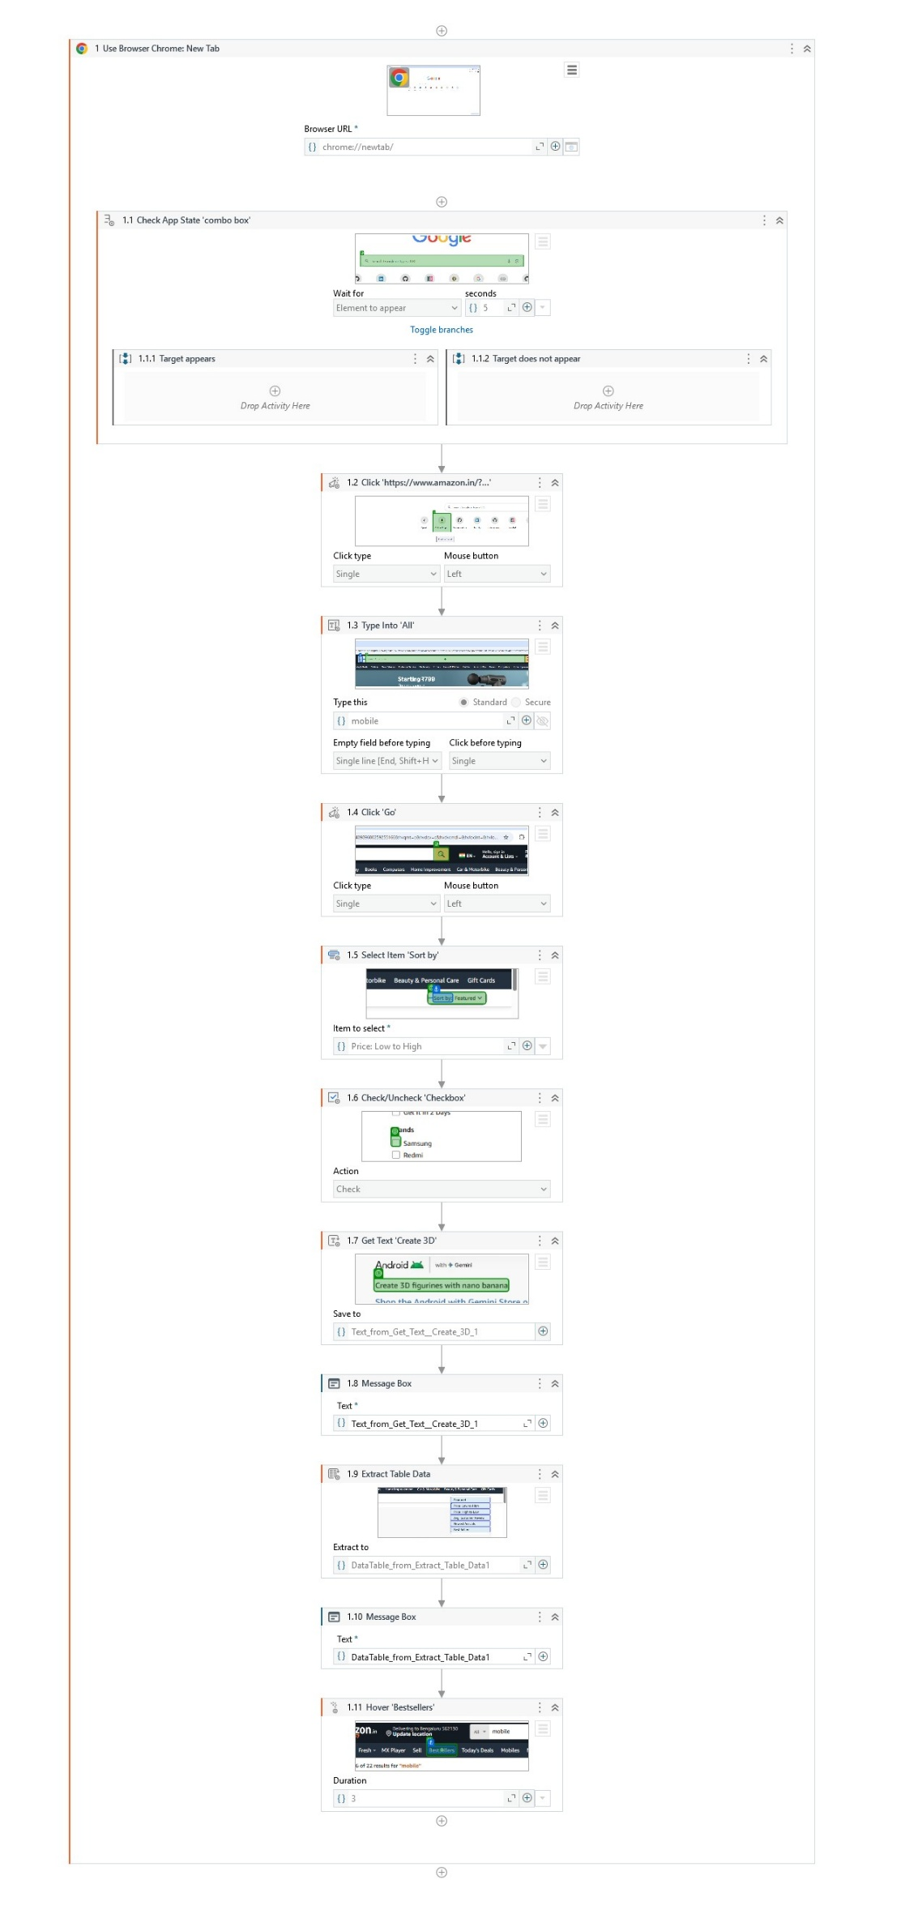
5. Develop UI automation in UiPath StudioX to demonstrate the following activities: Get Active Window, Maximize Window, Minimize Window, Hide Window, Restore Window and Move Window.

Step 1: Create a New Project
- Open UiPath StudioX from Start Menu.
- Click New Project → Blank Task.
- In the dialog box, give the Project Name as WindowAutomationDemo.
- Choose a folder location (e.g., Documents\UiPath).
- Click Create to open a new workspace.
Step 2: Use Application/Browser Activity
- In Activities panel, search Use Application/Browser.
- Drag it into the Main workflow.
- Click Indicate Application/Browser on Screen → select the target application (e.g., Notepad, Calculator, or a browser window).
Step 3: Get Active Window Activity
- Search Get Active Window → drag it inside the application scope.
- This captures the currently active window and allows further manipulation.
Step 4: Maximize Window Activity
- Search Maximize Window → drag it below Get Active Window.
- This maximizes the application window to full screen.
Step 5: Minimize Window Activity
- Search Minimize Window → drag it below Maximize Window.
- This minimizes the window to the taskbar.
Step 6: Hide Window Activity
- Search Hide Window → drag it below Minimize Window.
- This hides the window from view without closing it.
Step 7: Restore Window Activity
- Search Restore Window → drag it below Hide Window.
- This restores the window back to its original size and position.
Step 8: Move Window Activity
- Search Move Window → drag it below Restore Window.
- In properties, set X and Y coordinates to position the window at a specific location on the screen.
Step 9: Save and Run the Project
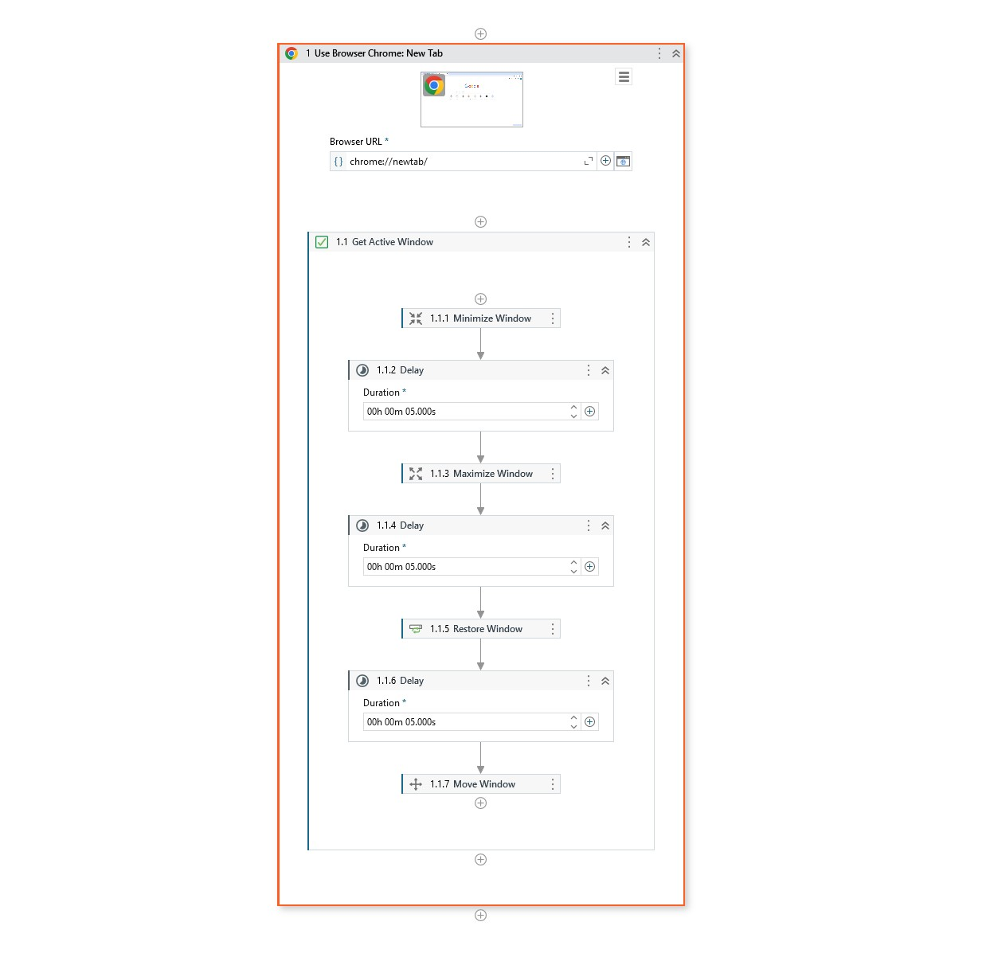

6. Develop Word automation in UiPath StudioX to demonstrate the following activities: Use Word File.., Save Document As, Read Text, Replace Text in Document, Append Text, Replace Picture, Add Picture, Save Document as PDF.

Step 1: Create a New Project
- Open UiPath StudioX from Start Menu.
- Click New Project → Blank Task.
- In the dialog box, give the Project Name as WordAutomationDemo.
- Choose a folder location (e.g., Documents\UiPath).
- Click Create to open a new workspace.
Step 2: Use Word File Activity
- In Activities panel, search Use Word File.
- Drag it into the Main workflow.
- Click Browse → select an existing Word document or create a new one.
- This sets the scope for all Word-related activities.
Step 3: Save Document As Activity
- Search Save Document As → drag it inside the Word scope.
- Specify a new file name (e.g., WordAutomation_Copy.docx).
- This creates a copy of the original document.
Step 4: Read Text Activity
- Search Read Text → drag it below Save Document As.
- This reads the content of the Word document into a variable (e.g., docText).
Step 5: Replace Text Activity
- Search Replace Text in Document → drag it below Read Text.
- Specify Text to Find (e.g., "UiPath") and Replacement Text (e.g., "StudioX").
- This updates text within the document.
Step 6: Append Text Activity
- Search Append Text → drag it below Replace Text.
- Enter the text to append at the end of the document (e.g., "Automation Completed Successfully.").
Step 7: Replace Picture Activity
- Search Replace Picture → drag it below Append Text.
- Indicate the picture to replace → select new image file.
Step 8: Add Picture Activity
- Search Add Picture → drag it below Replace Picture.
- Specify image file → position in the document as needed.
Step 9: Save Document as PDF Activity
- Search Save Document as PDF → drag it below Add Picture.
- Specify file path (e.g., C:\UiPath\WordAutomation.pdf).
- This exports the Word document as a PDF.
Step 10: Save and Run the Project

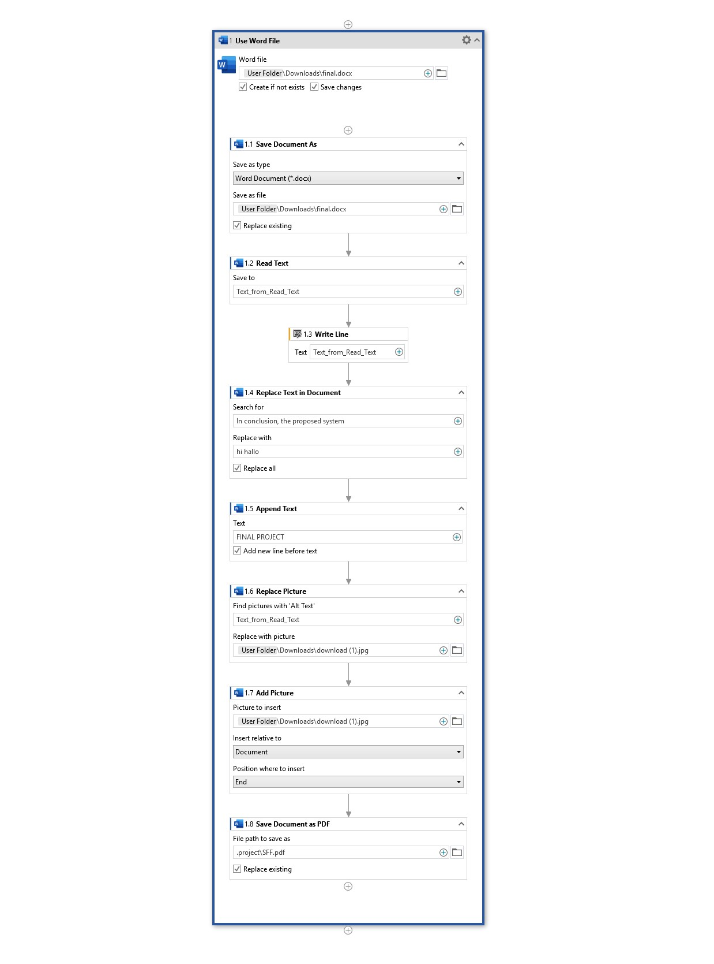

7. Develop Excel automation in UiPath StudioX to demonstrate the following activities: Use Excel File, Insert Sheet, Rename Sheet, Duplicate Sheet, Delete Sheet, For Each Excel Sheet, Insert Column, Text To Columns, Delete Column.

Step 1: Create a New Project
- Open UiPath StudioX from Start Menu.
- Click New Project → Blank Task.
- In the dialog box, give the Project Name as ExcelSheetOperations.
- Choose a folder location (e.g., Documents\UiPath).
- Click Create to open a new workspace.
Step 2: Use Excel File Activity
- In Activities panel, search Use Excel File.
- Drag it into the Main workflow.
- Click Browse → select an existing Excel workbook or create a new one.
- This sets the scope for all Excel sheet activities.
Step 3: Insert Sheet Activity
- Search Insert Sheet → drag it inside the Excel scope.
- Enter sheet name (e.g., "NewSheet1").
Step 4: Rename Sheet Activity
- Search Rename Sheet → drag it below Insert Sheet.
- Select the sheet to rename → enter new name (e.g., "RenamedSheet").
Step 5: Duplicate Sheet Activity
- Search Duplicate Sheet → drag it below Rename Sheet.
- Select the sheet to duplicate → new sheet copy will be created.
Step 6: Delete Sheet Activity
- Search Delete Sheet → drag it below Duplicate Sheet.
- Select the sheet to delete (e.g., temporary or test sheet).
Step 7: For Each Excel Sheet Activity
- Search For Each Excel Sheet → drag it below Delete Sheet.
- Inside loop → add Write Line → "Processing Sheet: " + CurrentSheet.Name.
- This iterates through all sheets in the workbook.
Step 8: Insert Column Activity
- Search Insert Column → drag it inside the For Each Excel Sheet loop.
- Specify position where column should be inserted (e.g., column A).
Step 9: Text To Columns Activity
- Search Text To Columns → drag it below Insert Column.
- Select column containing delimited text → specify delimiter (e.g., comma) → data is split into multiple columns.
Step 10: Delete Column Activity
- Search Delete Column → drag it below Text To Columns.
- Select the column to remove (e.g., temporary or test column).
Step 11: Save and Run the Project

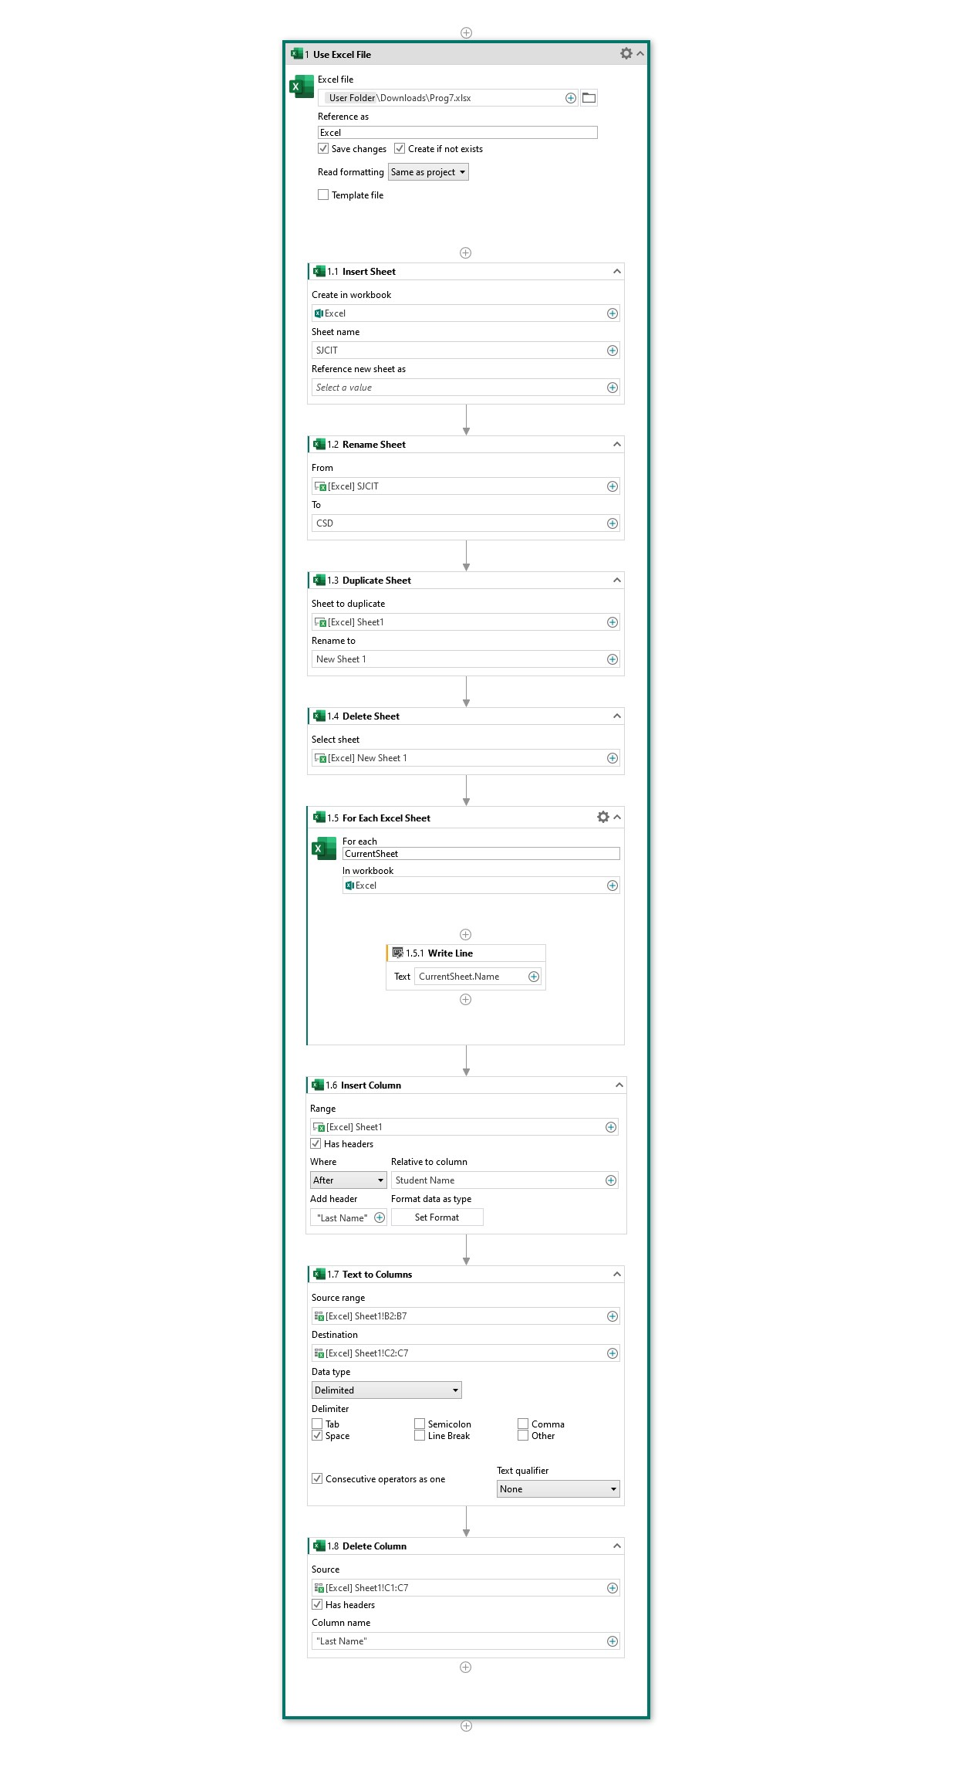
8. Develop Excel automation in UiPath StudioX to demonstrate the following activities: Insert Rows, Delete Rows, Find First/Last Data Row, For Each Excel Row, Write Cell, Create Pivot Table., Save Excel File As..., Save Excel File As PDF.

Step 1: Create a New Project
- Open UiPath StudioX from Start Menu.
- Click New Project → Blank Task.
- In the dialog box, give the Project Name as ExcelRowOperations.
- Choose a folder location (e.g., Documents\UiPath).
- Click Create to open a new workspace.
Step 2: Use Excel File Activity
- In Activities panel, search Use Excel File.
- Drag it into the Main workflow.
- Click Browse → select the Excel workbook to work with.
- This sets the scope for all Excel row activities.
Step 3: Insert Rows Activity
- Search Insert Rows → drag it inside the Excel scope.
- Specify the row position to insert new rows (e.g., row 2).
Step 4: Delete Rows Activity
- Search Delete Rows → drag it below Insert Rows.
- Specify the row(s) to delete (e.g., row 5).
Step 5: Find First/Last Data Row Activity
- Search Find First/Last Data Row → drag below Delete Rows.
- This retrieves the first and last row containing data → store in variables firstRow and lastRow.
Step 6: For Each Excel Row Activity
- Search For Each Excel Row → drag below Find First/Last Data Row.
- Select the range or sheet to iterate over.
- Inside loop → add Write Cell → write or update cell values (e.g., "Processed" in column C).
Step 7: Create Pivot Table Activity
- Search Create Pivot Table → drag it below the For Each loop.
- Specify source data range and target location for pivot table.
- Define row, column, and value fields as required.
Step 8: Save Excel File As Activity
- Search Save Excel File As → drag it below Pivot Table.
- Specify file name (e.g., ExcelRowOperations.xlsx) and location.
Step 9: Save Excel File As PDF Activity
- Search Save Excel File As PDF → drag it below Save Excel File As.
- Specify PDF file path (e.g., C:\UiPath\ExcelRowOperations.pdf).
Step 10: Save and Run the Project

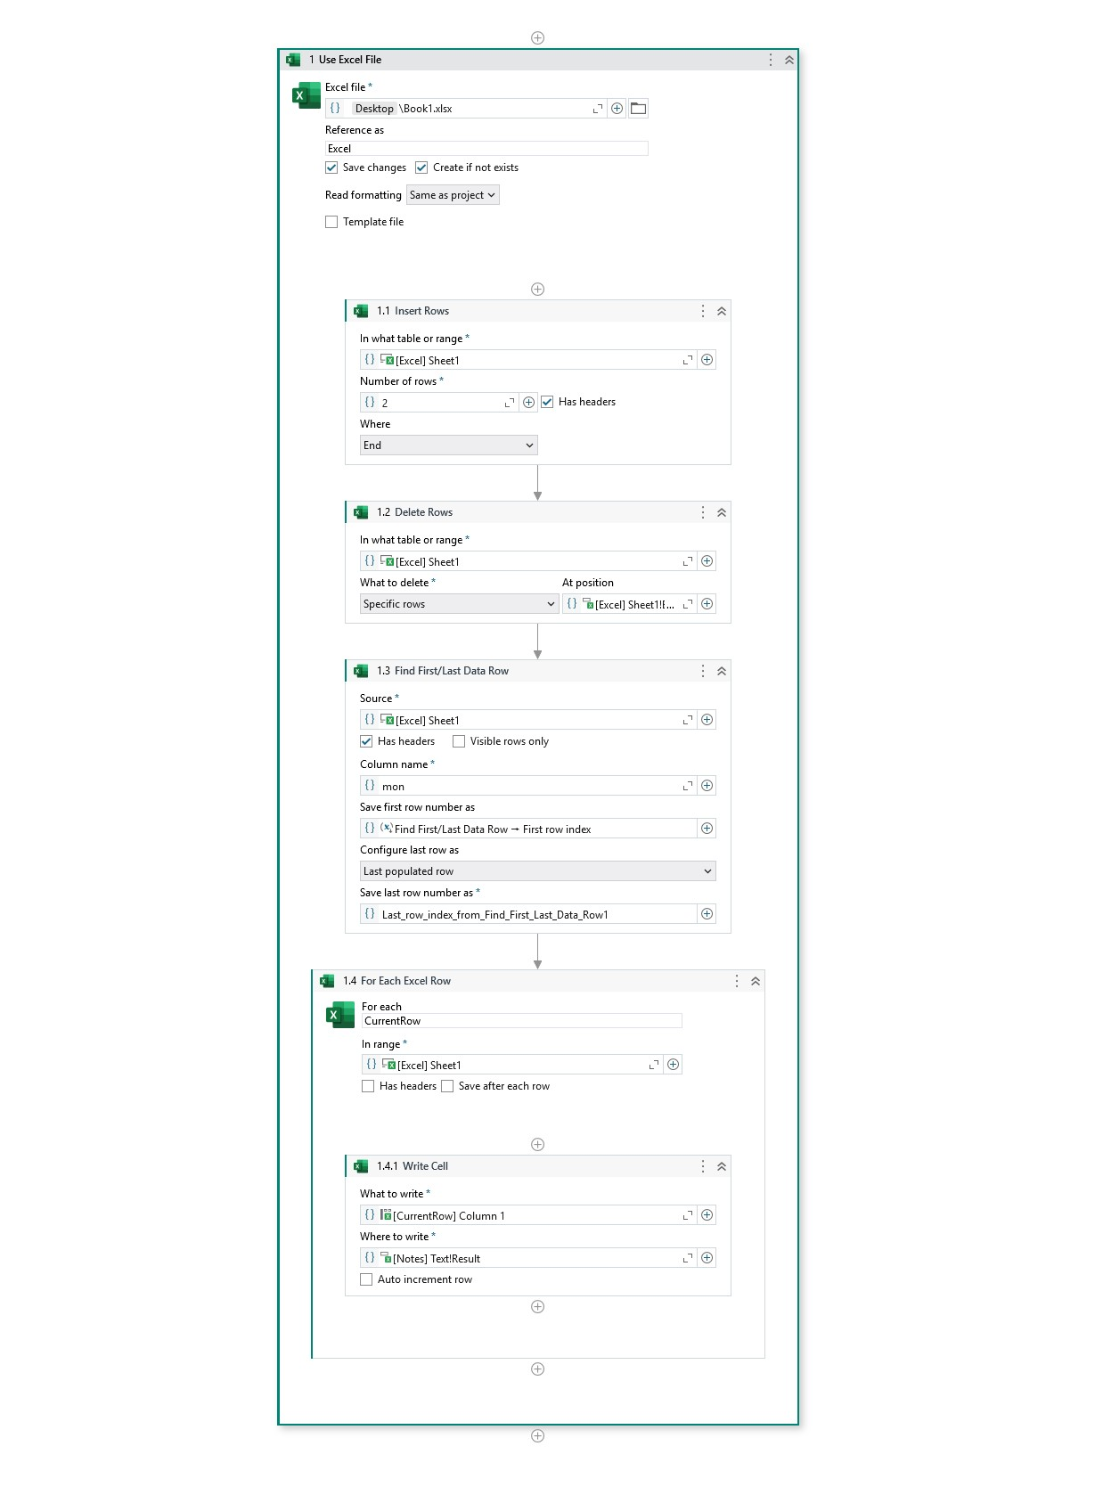

9. Develop Excel automation in UiPath StudioX to demonstrate the following activities: Use Excel File, Insert Sheet, Rename Sheet, Duplicate Sheet, Delete Sheet, For Each Excel Sheet, Insert Column, Text To Columns., Delete Column.

Step 1: Create a New Project
- Open UiPath StudioX from the Start Menu.
- Click New Project → Blank Task.
- In the dialog box, give the Project Name as ExcelSheetOperations.
- Choose a folder location (e.g., Documents\UiPath).
- Click Create to open the workspace.
Step 2: Use Excel File Activity
- In the Activities panel, search Use Excel File.
- Drag it into the Main workflow.
- Click Browse → select an existing Excel workbook or create a new one.
- This sets the scope for all Excel sheet operations.
Step 3: Insert Sheet Activity
- Search Insert Sheet → drag it into the Excel scope.
- Provide a new sheet name (e.g., "Sheet1").
Step 4: Rename Sheet Activity
- Search Rename Sheet → drag it below Insert Sheet.
- Select the sheet to rename → enter new name (e.g., "RenamedSheet").
Step 5: Duplicate Sheet Activity
- Search Duplicate Sheet → drag it below Rename Sheet.
- Select the sheet to duplicate → new copy is created automatically.
Step 6: Delete Sheet Activity
- Search Delete Sheet → drag it below Duplicate Sheet.
- Select the sheet to delete (temporary or test sheet).
Step 7: For Each Excel Sheet Activity
- Search For Each Excel Sheet → drag it below Delete Sheet.
- Inside loop → add Write Line → "Processing Sheet: " + CurrentSheet.Name.
- This allows iterating through all sheets for further operations.
Step 8: Insert Column Activity
- Search Insert Column → drag it inside the For Each Excel Sheet loop.
- Specify the position to insert (e.g., column A).
Step 9: Text To Columns Activity
- Search Text To Columns → drag it below Insert Column.
- Select the column containing delimited data → specify delimiter (e.g., comma) → splits data into multiple columns.
Step 10: Delete Column Activity
- Search Delete Column → drag it below Text To Columns.
- Select column to delete (e.g., temporary column after split).
Step 11: Save and Run the Project

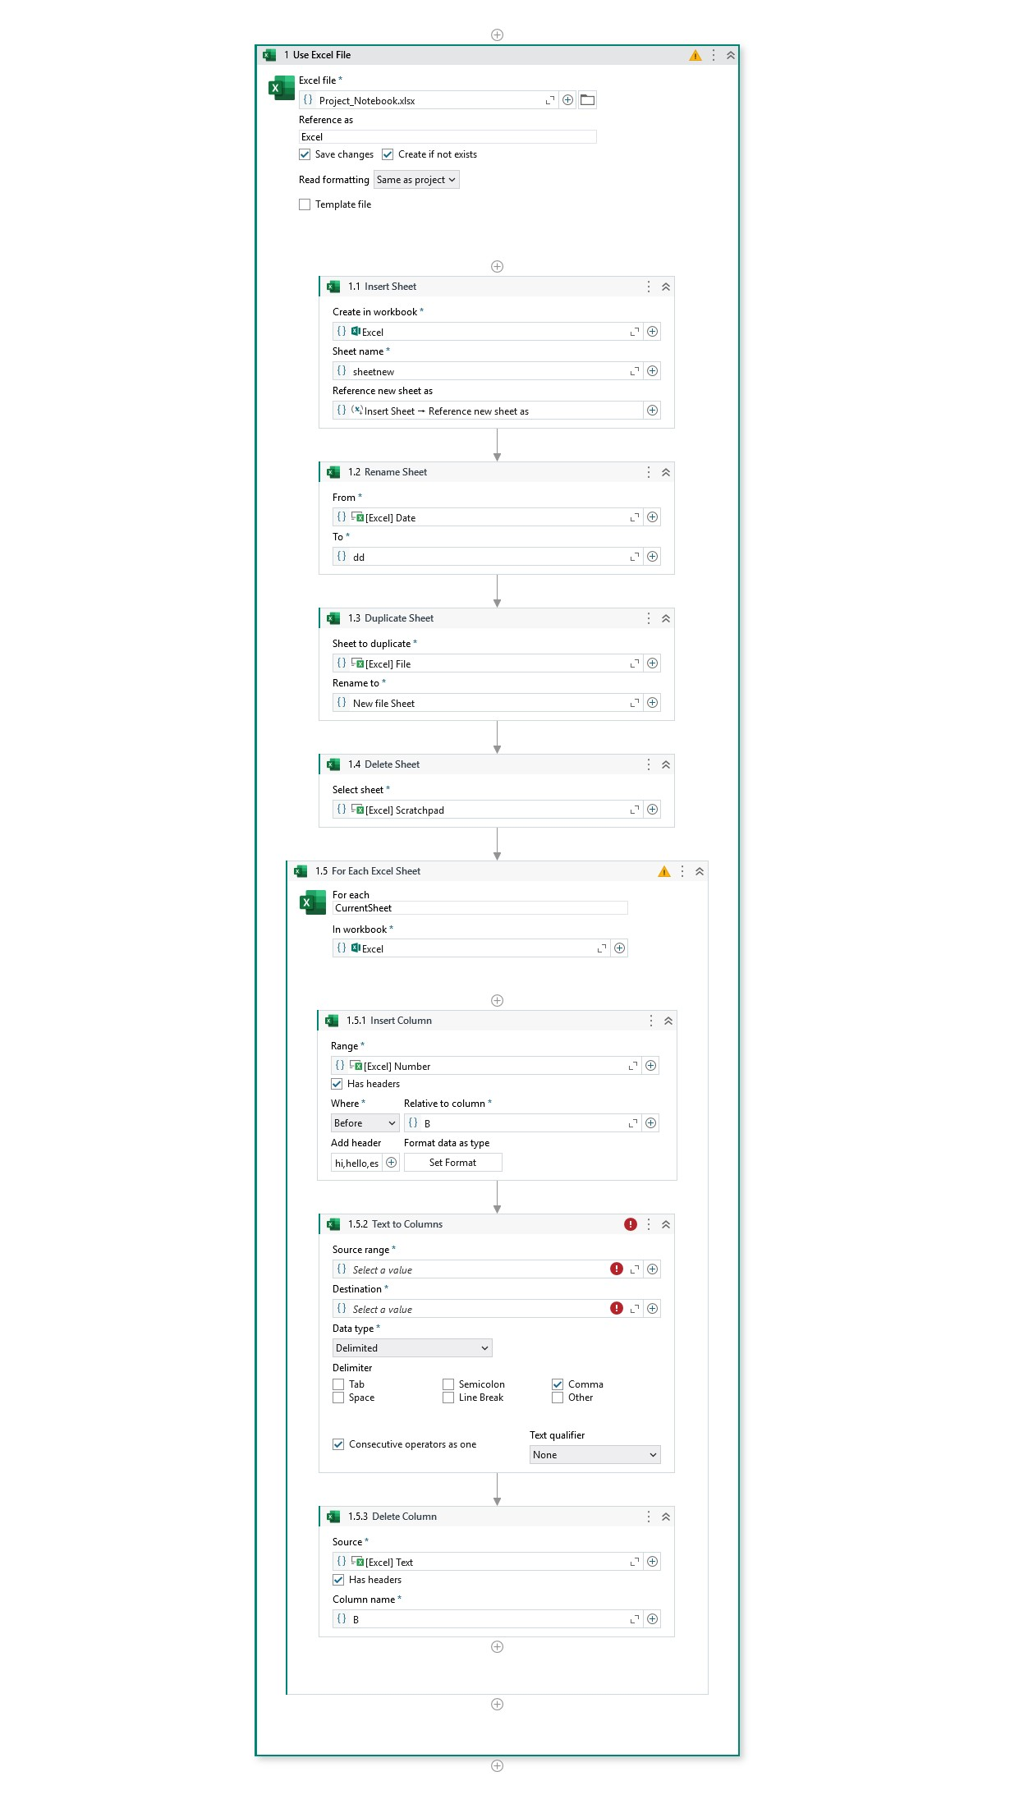
10. Develop Excel automation in UiPath StudioX to demonstrate the following activities: Refresh Pivot Table, Append Range, Copy Range, Sort Range, Clear Sheet/Range/Table, Auto Fill, Fill Range, Write Range, Read Cell Formula.., Read Cell Value, Format Cells, Export to CSV.

Step 1: Create a New Project
- Open UiPath StudioX from the Start Menu.
- Click New Project → Blank Task.
- In the dialog box, give the Project Name as ExcelAdvancedDemo.
- Choose a folder location (e.g., Documents\UiPath).
- Click Create to open the workspace.
Step 2: Use Excel File Activity
- Search Use Excel File → drag it into the Main workflow.
- Click Browse → select the Excel workbook to work with.
- This sets the scope for all Excel advanced activities.
Step 3: Refresh Pivot Table Activity
- Search Refresh Pivot Table → drag it inside Excel scope.
- Select the pivot table to refresh.
Step 4: Append Range Activity
- Search Append Range → drag it below Refresh Pivot Table.
- Specify source and target ranges to append data.
Step 5: Copy Range Activity
- Search Copy Range → drag it below Append Range.
- Specify the source range and destination range to copy data.
Step 6: Sort Range Activity
- Search Sort Range → drag it below Copy Range.
- Select the range → define sorting column(s) and order (Ascending/Descending).
Step 7: Clear Sheet/Range/Table Activity
- Search Clear Sheet/Range/Table → drag it below Sort Range.
- Specify the range or sheet to clear.
Step 8: Auto Fill Activity
- Search Auto Fill → drag it below Clear Range.
- Select source cell(s) → target range → auto-fill values/formulas.
Step 9: Fill Range Activity
- Search Fill Range → drag it below Auto Fill.
- Specify range → fill with specific value or formula.
Step 10: Write Range Activity
- Search Write Range → drag it below Fill Range.
- Specify target sheet/range → write data from a data table variable.
Step 11: Read Cell Formula Activity
- Search Read Cell Formula → drag it below Write Range.
- Specify cell → store formula in variable cellFormula.
Step 12: Read Cell Value Activity
- Search Read Cell Value → drag it below Read Cell Formula.
- Specify cell → store value in variable cellValue.
Step 13: Format Cells Activity
- Search Format Cells → drag it below Read Cell Value.
- Apply formatting (font, color, alignment, borders) to selected range.
Step 14: Export to CSV Activity
- Search Export to CSV → drag it below Format Cells.
- Specify file path (e.g., C:\UiPath\ExcelAdvanced.csv).
Step 15: Save and Run the Project

11. Develop File automation in UiPath StudioX to demonstrate the following activities: Get Folder Info, Folder Exists, , For Each File In Folder, Compress/Zip Files, Extract/Unzip Files, Get File Info, File Exists, Create File, Delete File, Copy File, Move File, Write Text File, Append Line.., Read Text File.

Step 1: Create a New Project
- Open UiPath StudioX from Start Menu.
- Click New Project → Blank Task.
- In the dialog box, give the Project Name as FileAutomationDemo.
- Choose a folder location (e.g., Documents\UiPath).
- Click Create to open the workspace.
Step 2: Get Folder Info Activity
- In Activities panel, search Get Folder Info → drag into Main workflow.
- Specify the folder path → output will provide folder details (e.g., creation date, size).
Step 3: Folder Exists Activity
- Search Folder Exists → drag it below Get Folder Info.
- Enter the folder path → store result in variable folderExists (Boolean).
Step 4: For Each File In Folder Activity
- Search For Each File In Folder → drag it below Folder Exists.
- Specify folder path → inside loop, add Write Line → "Processing File: " + CurrentFile.Name.
Step 5: Compress/Zip Files Activity
- Search Compress/Zip Files → drag it below the loop.
- Select files/folder → specify zip file path (e.g., C:\UiPath\Files.zip).
Step 6: Extract/Unzip Files Activity
- Search Extract/Unzip Files → drag below Compress.
- Select zip file → specify extraction folder path.
Step 7: Get File Info Activity
- Search Get File Info → drag below Extract/Unzip.
- Select file → output variable stores info like size, creation/modification date.
Step 8: File Exists Activity
- Search File Exists → drag it below Get File Info.
- Specify file path → store result in variable fileExists (Boolean).
Step 9: Create File Activity
- Search Create File → drag it below File Exists.
- Specify file path and name (e.g., C:\UiPath\NewFile.txt).
Step 10: Delete File Activity
- Search Delete File → drag it below Create File.
- Specify file path (e.g., test file to remove).
Step 11: Copy File Activity
- Search Copy File → drag it below Delete File.
- Specify source file and destination folder.
Step 12: Move File Activity
- Search Move File → drag it below Copy File.
- Specify source and destination paths → moves the file.
Step 13: Write Text File Activity
- Search Write Text File → drag it below Move File.
- Specify file path → enter text content to write.
Step 14: Append Line Activity
- Search Append Line → drag it below Write Text File.
- Specify file path → enter text to append at the end of the file.
Step 15: Read Text File Activity
- Search Read Text File → drag it below Append Line.
- Specify file path → store output in variable fileText.
Step 16: Save and Run the Project

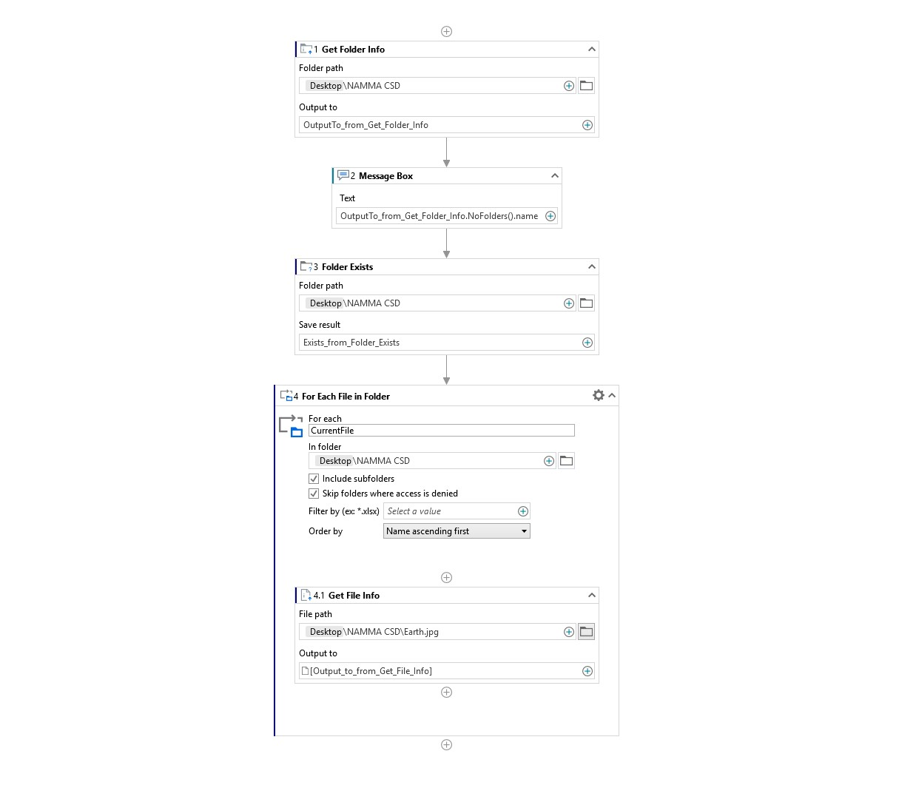

12. Develop Presentation automation in UiPath StudioX to demonstrate the following activities: Use PowerPoint Presentation, Copy Paste Slide, Delete Slide, Add New Slide, Add Text to Slide., Add Data Table to Slide, Add Image/Video to Slide, Save PowerPoint File As.,Save Presentation as PDF.

Step 1: Create a New Project
- Open UiPath StudioX from Start Menu.
- Click New Project → Blank Task.
- In the dialog box, give the Project Name as PresentationAutomationDemo.
- Choose a folder location (e.g., Documents\UiPath).
- Click Create to open the workspace.
Step 2: Use PowerPoint Presentation Activity
- In Activities panel, search Use PowerPoint Presentation.
- Drag it into the Main workflow.
- Click Browse → select an existing PowerPoint file or create a new one.
- This sets the scope for all presentation activities.
Step 3: Copy Paste Slide Activity
- Search Copy Paste Slide → drag it inside the PowerPoint scope.
- Select the slide to copy → specify target position → slide is duplicated.
Step 4: Delete Slide Activity
- Search Delete Slide → drag it below Copy Paste Slide.
- Select the slide to delete → it will be removed from presentation.
Step 5: Add New Slide Activity
- Search Add New Slide → drag it below Delete Slide.
- Choose slide layout → new blank slide is inserted.
Step 6: Add Text to Slide Activity
- Search Add Text to Slide → drag it below Add New Slide.
- Select slide → enter text content (e.g., "Automation Demo Slide").
Step 7: Add Data Table to Slide Activity
- Search Add Data Table to Slide → drag it below Add Text.
- Select slide → provide data table variable to display in slide.
Step 8: Add Image/Video to Slide Activity
- Search Add Image/Video to Slide → drag it below Add Data Table.
- Select slide → browse and insert image or video file.
Step 9: Save PowerPoint File As Activity
- Search Save PowerPoint File As → drag it below Add Image/Video.
- Specify file path and name (e.g., C:\UiPath\PresentationDemo.pptx).
Step 10: Save Presentation as PDF Activity
- Search Save Presentation as PDF → drag it below Save As.
- Specify PDF file path (e.g., C:\UiPath\PresentationDemo.pdf).
Step 11: Save and Run the Project

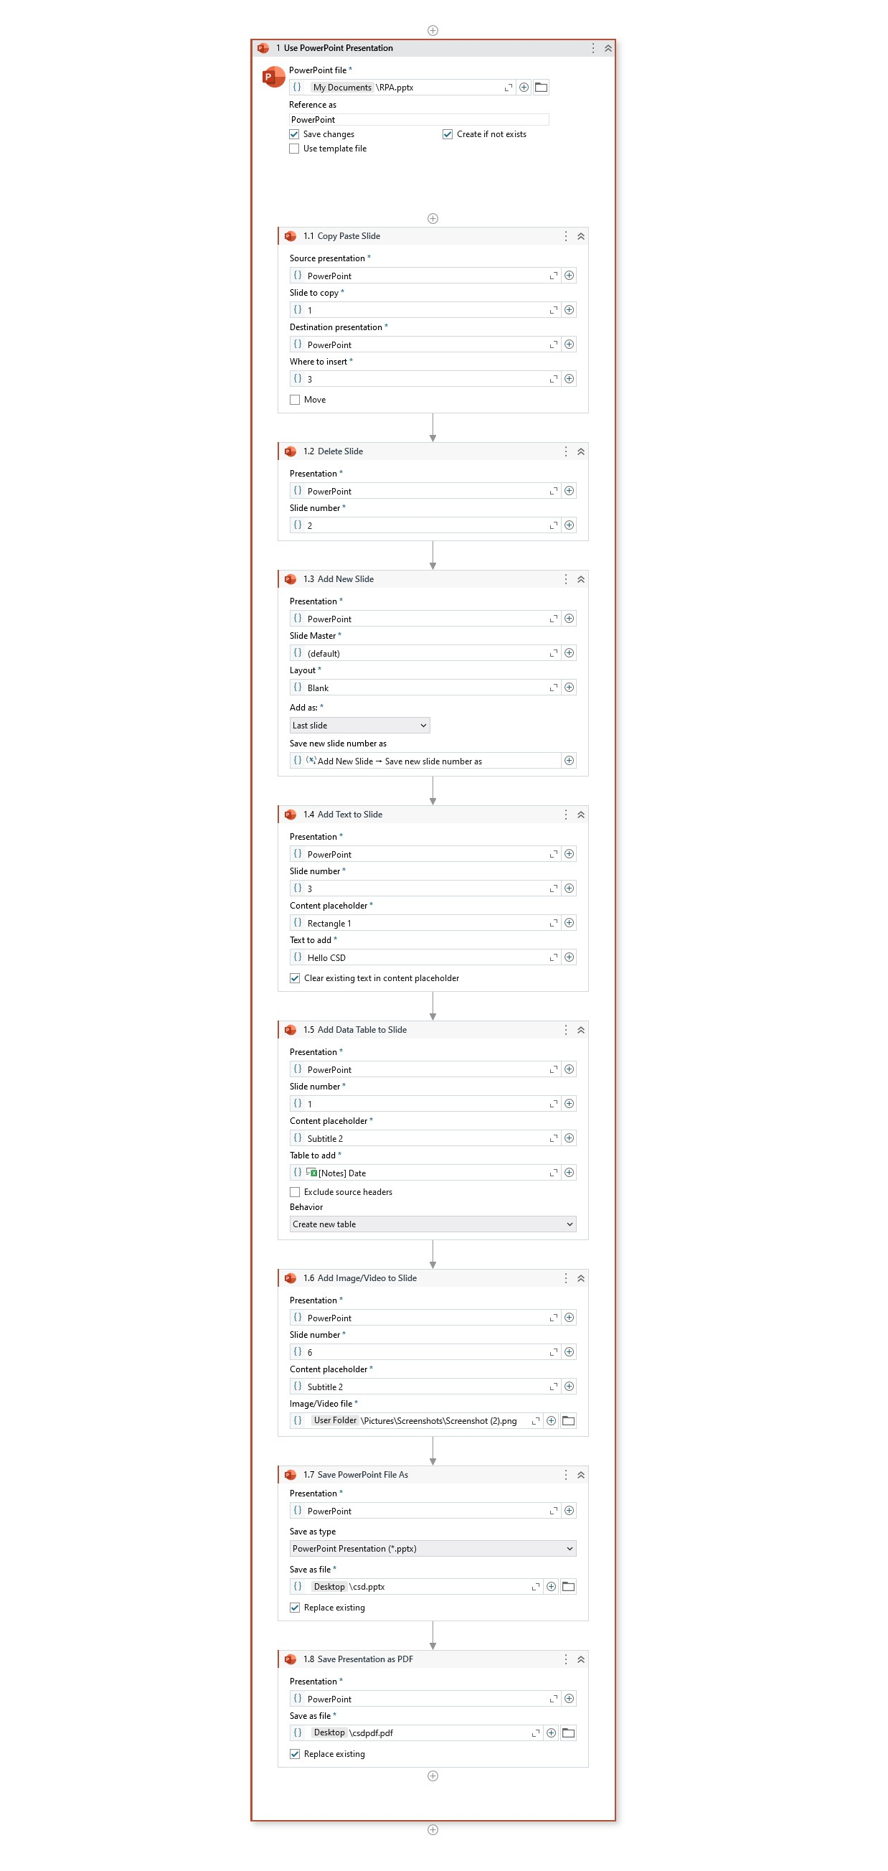
1. What is the purpose of the Write Line activity in UiPath?
It is used to display output or debug messages in the Output panel.

2. How does a Message Box differ from Write Line?
Message Box shows a popup dialog, while Write Line only writes in the Output panel.

3. What is the Input Dialog activity used for?
To take user input (text or numbers) during workflow execution.

4. What does Modify Text activity do?
It performs text operations like combining, replacing, or trimming strings.

5. What is Text to Left/Right used for?
It extracts text left or right of a delimiter, e.g., extracting first name from “John Doe”.

6. Why do we use the Delay activity?
To pause execution for a fixed duration, useful for synchronization with UI.

7. What is the output of the Basic Activities Demo?
Displays a final message greeting the user after processing their input.

8. What is the function of the If activity?
It allows the workflow to make decisions based on conditions (True/False).

9. How does the Switch activity work?
It executes different cases depending on the value of an expression.

10. What is Repeat Number of Times used for?
It repeats a block of activities a fixed number of times.

11. What is the difference between Skip Current and Exit Loop?

Skip Current: Skips the current iteration only.

Exit Loop: Stops the entire loop immediately.

12. What does CurrentIteration represent?
It gives the loop counter value of the current iteration.

13. Why do we use conditional statements in RPA?
To make automation workflows dynamic and responsive to input or data changes.

14. What does Use Application/Browser activity do?
It sets the browser or app window in which other activities will run.

15. What is the difference between Go To URL and Navigate Browser?

Go To URL: Opens a new website.

Navigate Browser: Changes the page in an already opened tab.

16. What is the purpose of the Highlight activity?
To visually highlight a UI element during automation to confirm targeting.

17. What does the Take Screenshot activity do?
Captures the current screen and saves it as an image file.

18. Why is browser automation useful in RPA?
It allows robots to interact with websites, perform data scraping, and automate web tasks.

19. What does Check App State activity verify?
It checks whether a UI element is visible or exists before performing actions.

20. What does Click activity do?
Simulates a mouse click on a button, link, or any clickable element.

21. How does the Type Into activity work?
It types text into input fields or editable boxes automatically.

22. What is the Select Item activity used for?
To select options from dropdown lists or combo boxes.

23. What is the difference between Check and Uncheck activity?

Check: Marks a checkbox as selected.

Uncheck: Deselects it if already checked.

24. What is Get Text used for?
To extract visible text from UI elements.

25. How is Get Attribute different from Get Text?
It retrieves element properties like tooltip, ID, or inner text.

26. What is Extract Table Data used for?
To extract structured data from tables into a DataTable variable.

27. What does the Hover activity do?
Moves the mouse pointer over an element to trigger hover effects.

28. What does Get Active Window return?
It returns a reference to the currently active window.

29. What is Maximize Window used for?
To enlarge the application window to full screen.

30. How does Minimize Window help?
It minimizes a window to the taskbar during automation.

31. What does Hide Window do?
Temporarily hides a window without closing it.

32. What is Restore Window used for?
Restores a minimized or maximized window to its normal size.

33. What is the function of Move Window?
To reposition a window on screen using X and Y coordinates.

34. What does Use Word File activity define?
The scope of all Word-related actions like read, write, replace, etc.

35. What is Save Document As used for?
To save a copy of the Word document with a new name or location.

36. What does Read Text do in Word Automation?
It reads the entire document text into a variable.

37. What is the Replace Text in Document activity for?
To find and replace words or phrases automatically in a Word file.

38. How is Append Text different from Replace Text?
Append Text adds content at the end, while Replace Text modifies existing content.

39. What is Replace Picture activity used for?
To swap an existing image in a Word document with a new one.

40. How do you add a new image in Word using UiPath?
By using Add Picture and specifying the image path and position.

41. How to convert a Word document into PDF?
Using the Save Document as PDF activity.

42. What is Use Excel File activity for?
It defines the scope for Excel automation activities.

43. What is Insert Sheet used for?
To create a new blank sheet in a workbook.

44. What does Rename Sheet do?
Changes the name of an existing worksheet.

45. What is Duplicate Sheet?
It copies an existing sheet with data and formatting.

46. What does Delete Sheet do?
It removes unwanted or temporary sheets from the workbook.

47. What does For Each Excel Sheet activity do?
It loops through all worksheets in a workbook.

48. What does Insert Column activity do?
It adds a new column at the specified position.

49. What is Text to Columns used for?
To split text from one column into multiple columns based on a delimiter.

50. What does Delete Column do?
Removes a specified column from the worksheet.

51. What is Insert Rows activity used for?
To add new rows at a specific position in the sheet.

52. What does Delete Rows activity do?
It removes unwanted rows based on given position or range.

53. What is Find First/Last Data Row?
It identifies the first and last rows containing data in a range.

54. What is For Each Excel Row used for?
To iterate through all rows in a range or table for processing.

55. What is Create Pivot Table activity used for?
It creates a Pivot Table to summarize and analyze data.

56. How can you save Excel as a new file or in PDF format?
Using Save Excel File As and Save Excel File As PDF activities.

57. What does Refresh Pivot Table do?
It updates the Pivot Table with latest source data.

58. What are Append Range and Copy Range used for?

Append Range: Adds new data below existing data.

Copy Range: Duplicates data from one range to another.

59. What is the use of Sort Range?
To sort data in ascending or descending order based on a column.

60. What does Export to CSV activity do?
It saves Excel data in CSV format for sharing or database import.

61. What is Get Folder Info used for?
Retrieves folder details like size, creation date, and path.

62. What does Folder Exists activity check?
It verifies if a folder is present in the given location.

63. What is For Each File In Folder used for?
Loops through all files in a folder for processing.

64. What is the function of Compress/Zip Files?
To zip multiple files into a single archive.

65. What does Extract/Unzip Files do?
It decompresses files from a zip archive.

66. What is Get File Info used for?
Retrieves file details like name, size, and modified date.

67. What does File Exists check?
Checks whether a specific file exists.

68. What does Create File do?
Creates a new blank file at the specified location.

69. What is Delete File used for?
Deletes a specific file permanently or temporarily.

70. What do Copy File and Move File do?

Copy File: Makes a duplicate in another location.

Move File: Transfers the file to a new location.

71. What does Write Text File do?
Creates or overwrites a text file with specified content.

72. What is Append Line used for?
Adds new lines to an existing text file.

73. What does Read Text File do?
Reads and stores file contents into a string variable.

74. What is Use PowerPoint Presentation activity used for?
It defines the scope for all PowerPoint-related activities.

75. What does Copy Paste Slide do?
Duplicates a selected slide and pastes it to another location.

76. What is Delete Slide activity used for?
Removes unwanted slides from a presentation.

77. What is Add New Slide used for?
Inserts a new blank slide with a chosen layout.

78. What does Add Text to Slide do?
Inserts text into a specific slide placeholder.

79. What is Add Data Table to Slide used for?
Adds a data table object to a slide using table data.

80. What does Add Image/Video to Slide do?
Inserts multimedia content into a PowerPoint slide.

81. What is Save PowerPoint File As used for?
Saves a new copy of the presentation with a specified name/path.

82. How can you save a PowerPoint presentation as a PDF?
Using the Save Presentation as PDF activity.

83. What is RPA?
Robotic Process Automation — it automates repetitive digital tasks using software robots.

84. What is UiPath StudioX?
A low-code automation tool for business users and citizen developers.

85. Difference between UiPath Studio and StudioX?

Studio: For developers with advanced features.

StudioX: Simplified, business-friendly interface.

86. What are variables in UiPath?
Variables are data containers used to store values temporarily during automation.

87. What is a workflow?
A sequence of activities designed to perform an automation task.

88. What is meant by scope in UiPath?
The range or boundary within which a variable or activity is accessible.

89. What are arguments?
Used to pass data between workflows or components.

90. What is DataTable used for in UiPath?
To store and process tabular data like Excel sheets.

